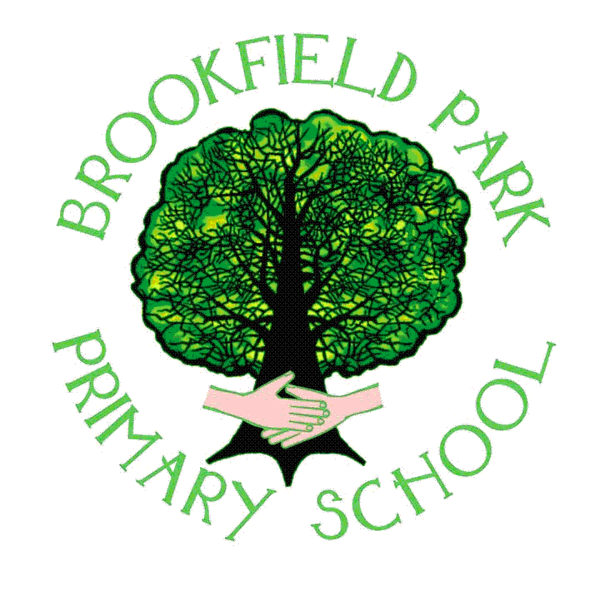

Brookfield Park Primary School
Behaviour Policy – September 2025
- Policy Statement of Intent
The aim of school discipline is to encourage every pupil to behave in a responsible manner based on a concern for the rights of other individuals and to lead pupils to exercise self-discipline. At Brookfield Park Primary School we aim to foster a tolerant, caring attitude and expect pupils to behave in a respectful and considerate way towards others.

Our school behaviour policy is written with all members of the school community in mind including pupils, parents/carers, grandparents, visitor’s and all staff. School should be a happy and secure place for all.

All pupils have the right to an education that offers them the best opportunities to work hard, be happy and make good progress. We are committed to enabling all of our pupils to access their education successfully by ensuring we have clear expectations of behaviour which are consistent and therefore minimise disruption to learning.

All staff endeavour to create the right environment and opportunities for this to happen. Many others contribute towards this process. Our school values are an integral part of this environment and the vast majority of pupils do support and contribute to these values by making positive choices and behaving appropriately.

However, as in many schools, there are individuals who, for a variety of complex reasons, have difficulty following the rules and present more challenging behaviour. Generally, these pupils require a wide range of approaches to help support them in school. It is important to create and maintain, as far as possible, a purposeful, orderly and safe learning environment for all pupils, including those with social, emotional and behavioural difficulties; therefore, behaviour strategies may differ for pupils with identified SEN. These strategies will be identified on a SEND or Individual behaviour plan. It is important to note however that all pupils, regardless of additional needs, are required to follow the same rules and behave in the same way as the rest of the school community.

At Brookfield Park Primary school we are committed to:

• Promoting desired behaviour
• Promoting self-esteem, self-discipline, proper regard for authority, and positive
relationships based on mutual respect
• Ensuring equality and fair treatment for all
• Praising and rewarding good behaviour
• Challenging and disciplining misbehaviour
• Providing a safe environment, free from disruption, violence, discrimination, bullying and
any form of harassment
• Encouraging positive relationships with parents
• Developing positive relationships with pupils to enable early intervention
• A shared approach which involves pupils in the implementation of the school’s policy and
associated procedures
• Promoting a culture of praise and encouragement in which all pupils can achieve
• Providing opportunities for pupils to reflect on their behaviour, take responsibility for their choices and make amends

The principles and sanctions outlined in this policy will be consistently and fairly applied to all pupils.

- Legal framework

This policy has due regard to all relevant legislation and statutory guidance including:
• Education Act 1996
• Education Act 2002
• Equality Act 2010
• Educations and Inspections Act 2006
• Health Act 2006
• The School Information (England) Regulations 2008
• DfE (2016) ‘Behaviour and discipline in schools’
• DfE (2018) ‘Sexual violence and sexual harassment between children in schools and colleges’
• DfE (2018) ‘Mental health and behaviour in schools’
• DfE (2015) ‘Special educational needs and disability code of practice: 0 to 25 years’
• DfE (2013) ‘Use of reasonable force’

This policy acts in conjunction with the following school policies:

- Anti-Bullying Policy
- Special Educational Needs and Disabilities (SEND) Policy
- Child Protection and Safeguarding Policy
- Complaints Procedures Policy
- Communication policy

- Roles and responsibilities
At Brookfield Park Primary School, discipline is recognised to be a collective responsibility
between parents, staff, governing body, pupils and other agencies involved with school. It is
vital that the behaviour policy is clear, fully understood by staff, parents and pupils and consistently applied. If this partnership is working effectively then we expect:

Parents and families:
• By reading this policy and sending your child(ren) to Brookfield Park you agree to abide by
this policy in full
• To co-operate with school staff at all times
• To ensure children's regular attendance and punctuality
• To encourage their children to show respect and support the school’s authority to
discipline children
- To approach school staff courteously when wanting to discuss any issues
- To make an appointment to discuss concerns at an appropriate time in an appropriate manner
Pupils:
- Conducting themselves in a way which keeps themselves and others safe from harm
- To take responsibility for their own actions
- To move in an orderly manner around school
- To show respect for people and property
- To demonstrate appropriate levels of concentration and self-discipline
- To co-operate with and respond to the school’s behaviour policy
- To be polite, considerate and caring
Staff:
• To consistently follow and apply the behaviour policy
• To develop an effective working atmosphere
• The Head teacher fully supports the staff in the implementation of this policy
The Governing Body:
- To support the head teacher and staff in the implementation of this Behaviour Policy.

- The Brookfield Park Promise (Appendix 1)
We promise to…
Be Kind
Be Resilient
Be Safe
Take Ownership
Show respect
Our Brookfield Park Promise was drawn up by all members of the school community and incorporates the main behaviours we want to promote to enable the school to function efficiently as a place of learning and to ensure the safety and well-being of pupils and adults. The Promise is displayed in each classroom and throughout the school, and discussed regularly and appropriately with all pupils, depending on their age and ability.
- Promoting Positive Behaviour
At Brookfield Park Primary School we feel that acknowledging and rewarding good behaviour is a fundamental part of providing a happy and secure environment that promotes learning, confidence and self-esteem amongst the pupils. In order to encourage the pupils to practice good behaviour, we operate a system of praise and reward. This system is available for all pupils using a variety of strategies dependent on their age.
Pupils at Brookfield Park can be rewarded for academic and non-academic achievements, e.g. for effort, for demonstrating improvement or helpfulness, attendance or punctuality, good manners, resilience and making best choices when it comes to sorting out conflicts with peers. Incentives range from House Points through to certificates, stickers and praise.
Although we use rewards to recognise, embed and teach good behaviour, our ultimate aim is for every child to recognise that good behaviour is an expectation, not simply a method to earn a reward and for them to understand how their behaviour impacts on others.
PSHRE lessons
A weekly PSHRE lesson is timetabled in all classes. This is central to teaching and promotes the behaviours expected in school, as well as teaching children strategies to support their self-regulation, developing resilience, raising self-esteem and giving them strategies to deal with conflict when it arises.
- Procedures for dealing with unacceptable behaviour
Whilst we aim to always reward positive behaviour, we acknowledge that there will be times when we have to deal to with behaviour that is unacceptable.
As with rewards for positive behaviour, it is vitally important that we deal with any
unacceptable behaviour in an agreed and consistent way. It is also important that parents
play their full part in ensuring the good behaviour of their children whilst at school.
When a child misbehaves our response will depend upon the severity of the incident.

Our Expectations  (Brookfield Park Promise) | Consistent strategies to promote this | Over and above recognition
We promise to:  - Be Kind  - Be Resilient  - Be Safe  - Take Ownership  - Show Respect | - Daily meet and greet  - Persistently picking up on children doing the right thing  - Picking up in children that are failing to meet expectations  - Accompanying the children to and from the playground at break and lunch  - Praising in public and reminding in private.  - Consistent use of language by all staff  House points | - Certificates – Pupil of the week  - Stickers  - Notes home  - SLT praise  - Class rewards  - DHT/HT award

Stepped boundaries – Gentle approach, use child’s name, child level, eye contact, deliver message
- REMINDER | I noticed you chose to ….(noticed behaviour)  This is a REMINDER that you need to …. (Be Kind, Be Resilient, Be Safe, Take Ownership, Show Respect)  You now have the chance to make a better choice  Thank you  Example – “I notice that you are running. Remember you need to be safe. Thank you”
- WARNING | I noticed you chose to….(noticed behaviour)  This is the second time I have spoken to you  I will speak to you in a moment  If you choose to behave in a way that does not meet our expectations again then you will have to go in to reflection.  Remember ……… (give an example of the desired behaviour). That is the behaviour I expect from .  you. Think carefully. I know you can make good choices. Thank you.  Example – “I have noticed you are not ready to do your work. Remember you need to take ownership. You will have to complete reflection if you continue with this behaviour. Remember yesterday when you settled to your work straight away and finished it? That is the behaviour I expect from you today. Thank you.
- REFLECTION | I noticed you chose to …. (noticed behaviour)  You need to go in to the reflection area to complete reflection.  If on playground – You need to stand by me and then go straight to reflection when we get in or if at lunchtime – I will be speaking to you class teacher and you will need to complete reflection when you go in after lunch.  Example – “I notice you have chosen to use inappropriate language. That is not showing respect. You have now chosen to have some reflection time. Go to reflection and I will come and speak to you when you have completed your reflection sheet. Thank you”  In EYFS/KS1 reflection will need to be done with an adult. Children can sit in reflection area and think about what happened until an adult gets to them.  If a child has been in reflection then the class teacher or staff member who has dealt with the incident must make the parent aware of this. This can be done face to face or via text message.
- FOLLOW UP – REPAIR AND RESTORE | A member of staff must follow up after the reflection has been completed and talk to the child about it (even if this is not straight away e.g. at beginning of play/lunch or assembly time).  Focus on:  - What happened? (Factual and neutral, dispassionate language)  - What were you feeling at the time?  - What have you felt since?  - How did this make people feel?  - Who has been affected?  - What should we do to out things right?  - How can we do things differently?

Extreme behaviours

These stepped boundaries should be implemented for any behaviours that do not meet the expectations of the school promise. There may be instances where a more severe consequence is needed and in these extreme cases, a different consequence may need to be considered e.g. some time out in a different class or key stage, or if severe a possible fixed term exclusion. SLT will be the ones that will decide upon of appropriate consequence on these occasions. Staff should not send for a member of SLT until the agreed stepped boundaries have been followed or unless a child is displaying behaviour that endangers themselves or others.

In very rare and extreme cases, where behaviour is persistent in spite of support and consequences put in place and where the child is at risk of permanent exclusion, school may reach out to the local authority to try to secure a ‘managed move’. Only when all other avenues have been exhausted, will a permanent exclusion will be considered.

Recognising the impact of SEND/other needs on behaviour.

The school recognises that some pupils’ behaviours may be impacted by a special educational need or disability (SEND) or other factors (e.g. ACE’S, family circumstances) . When incidents of mis behaviours arise, we will consider them in relation to a pupil’s SEND and or other circumstances, although we recognise that not every incident of misbehaviour will be connected to this. Decisions about whether a pupil’s SEND/other need had an impact on an incident of misbehaviour will be made on a case-by-case basis. When dealing with misbehaviour from pupils with SEND/other needs, especially where this affects their behaviour, the school will balance their legal duties when making decisions about enforcing the behaviour policy.

The legal duties include:
• Taking reasonable steps to avoid causing any substantial disadvantage to a disabled pupil caused by the school’s policies or practices (Equality Act 2010)
• Using our best endeavours to meet the needs of pupils with SEND (Children and Families Act 2014)
• If a pupil has an education, health and care (EHC) plan, the provisions set out in that plan must be secured and the school must co-operate with the local authority and other bodies.

As part of meeting these duties, the school will anticipate, as far as possible, all likely triggers of misbehaviour, and put in place support to prevent these from occurring. Any preventative measures will take into account the specific circumstances and requirements of the pupil concerned.
These may include:
• Short, planned movement breaks for a pupil with SEND who finds it difficult to sit still for long
• Adjusting seating plans to allow a pupil with visual or hearing impairment to sit in sight of the teacher
• Training for staff in understanding conditions such as autism
- Use of calm spaces where pupils can regulate their emotions during a moment of sensory overload
- Sensory diet activities

Year 1/EYFS – In our Year 1 class and EYFS unit, pupils will be expected to follow the same rules as the rest of school, however due to their age, behaviour sanctions will be instant and will involve time out from activities, missed playtime or other appropriate sanctions but the time out will be followed up by a discussion with a member of staff using the reflection format questions.

- Confiscation of inappropriate items

There are two sets of legal provisions, which enable school staff to confiscate items from pupils:
- The general power to discipline enables a member of staff to confiscate, retain or dispose of a pupil’s property as a punishment and protects them from liability for damage to, or loss of, any confiscated items.
- Power to search without consent for “prohibited items” including:
• knives and weapons
• alcohol
• illegal drugs
• stolen items
• tobacco and cigarette papers
• fireworks
• pornographic images
• any article that has been or is likely to be used to commit an offence, cause personal injury or damage to property
• any item banned by the school rules which has been identified in the rules as an item which may be searched for.

Weapons, knives and pornography (including child pornography) will be handed to the police.

- Power to use Reasonable Force
At Brookfield Park Primary we do not have a ‘no contact’ policy as there is a real risk that such a policy might place a member of staff in breach of their duty of care towards a pupil or prevent them from taking action when needed in order to prevent a pupil causing themselves or others harm. Children who present an ongoing or frequent risk of causing themselves or others harm are subject to a Risk Assessment that leads to a ‘Positive Handling Plan’ (PHP). This outlines the de-escalation and positive handling techniques and strategies to be used with the child. It is signed and agreed by parents/carers and reviewed regularly.
School staff have a legal power to use reasonable force. We acknowledge there may be rare situations whereby a child requires physical restraint. This form of restraint is known as positive handling. There are identified staff within the school who have up to date training on safe physical restraint techniques but this does not mean that they are the only members with the authority to use reasonable force. Incidents where reasonable force was used are recorded on CPOMS. In all cases, staff will assess any given situation before employing reasonable, proportionate and necessary force in the circumstance for the shortest possible period of time. Key members of staff have completed Team Teach training.
- Monitoring and Evaluation
This policy will be reviewed annually at the start of each academic year with mid-year reviews where monitoring indicates that this is required.
Following the annual review of the policy, parents will be advised about any adaptions or changes and the website will be utilised to ensure the principles of the behaviour policy remain high profile for the whole school community.

Policy Written September 2025
Next review September 2026

