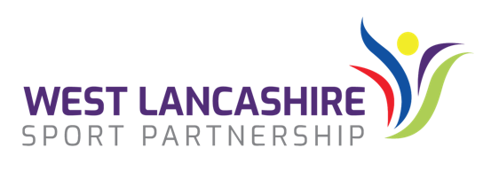
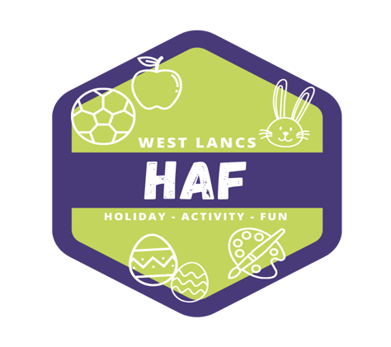

15th March 2023

Dear Parents and Carers

We are writing to let you know of a fantastic opportunity for your child to access FREE activities and holiday camps over the Easter holidays between Tuesday 11th and Friday 14th April 2023.

Due to government funding, we can offer eligible children free places at our holiday activities and camps delivered by a variety of providers across West Lancashire. We are pleased to let you know that your child is eligible for a free place. Places will be allocated on a first come first served basis, so we would encourage you to sign up for these places as soon as possible. All activities will include a free lunch as part of the offer.

Camps and activities are running at various locations across West Lancashire, in order to ensure that as many children as possible can access these opportunities. Eligible children can access any site or activity.

To see what is on offer, please visit the brand new West Lancs HAF website at:
https://westlancashirehaf.com
You can check your child’s eligibility and book your place on this website. Bookings will be open from the 15th March 2023 and close at 5pm on Wednesday 29th March 2023. Please complete the booking form fully in order to reserve your child’s place.

We are also providing free access to a whole range of activity videos and downloadable activity sheets from our Lancashire HAF Online website, which is available at: https://lancashirehafonline.com

We look forward to seeing your child there to enjoy a fun packed Easter 2023!

Yours faithfully

The West Lancashire HAF Team

