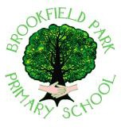

School Lane Campus School Lane, Skelmersdale, Lancashire, WN8 8EH
tel: 01695 724042 fax: (01695) 550738

email: head@brookfieldpark.lancs.sch.uk

Head teacher: Mrs Sarah-Jane Whiteside, Bed (Hons)

Dear Parent/Carer,
We would like to share some important information about the 30 hours of free childcare available for eligible families.
This funding is for working parents of 2, 3 and 4-year-old children. It offers an extra 15 hours of free childcare per week, on top of the 15 hours all families already get.

Who Can Get 30 Hours Free Childcare?
To qualify, you must meet the following conditions:
- Both parents must be working and each parent must earn at least the National Minimum Wage or Living Wage for 16 hours a week.
- OR one parent in a single parent household must be working and earning at least the National Minimum Wage or Living Wage for 16 hours a week.
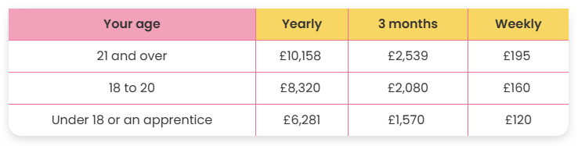
You can still apply if you are:
- On maternity, paternity, or adoption leave
- On sick or annual leave
- Starting a new job soon

How to Apply:
You can apply online at https://www.childcarechoices.gov.uk. If you are eligible, you will receive a code which you must give to the school office.
Please apply as early as possible before the start of the next term.
If you need help or have questions, feel free to contact Miss Chivers or Miss Rooney

