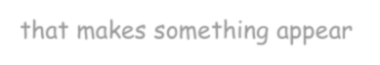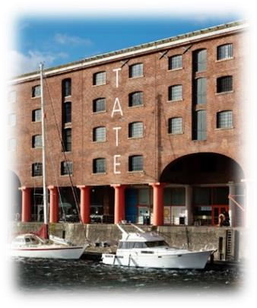

Talk about our
k
ey
v
ocabulary

at home.

Visit the Tate Liverpool to
view
a collect
ion of
sculptures by
Barbara
Hepworth

including
‘Curved Form’.

Optical
Illusion
:

In optical
-
illusion art, artists

use shapes, colours and
patterns in special ways to
create images that look as if
they are moving or blurring.
Lenticular
-
Printing
:

A printing method that, when
the image is viewed at different
angles, th
e objects either look
D or changes
3

appeara
nce.
Distort
:

A distortion is an alteration

that makes something appear
different from the way

that

it
really is.

Chinoiserie

:

Chinoiserie is a Wester
n style
of decorative art that drew
upon Chinese motifs and
techniques
.

Curate
:

To curate means to

select,
organize and look after the
objects or works of art in a
museum or an art gallery
.

