Year 5 Art and Design Curriculum Booklet

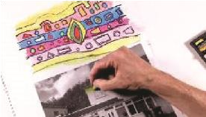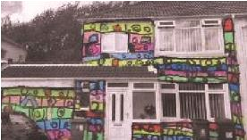

National Curriculum for Art and Design:
Key Stage 2

The national curriculum for art and design aims to ensure that all pupils:
- produce creative work, exploring their ideas and recording their experiences
- become proficient in drawing, painting, sculpture and other art, craft and design techniques
- evaluate and analyse creative works using the language of art, craft and design
- know about great artists, craft makers and designers, and understand the historical and cultural development of their art forms.

Pupils should be taught to develop their techniques, including their control and their use of materials, with creativity, experimentation and an increasing awareness of different kinds of art, craft and design.
Pupils should be taught:
- to create sketch books to record their observations and use them to review and revisit ideas
- to improve their mastery of art and design techniques, including drawing, painting and sculpture with a range of materials [for example, pencil, charcoal, paint, clay]
- about great artists, architects and designers in history.
Year 5: Autumn Term
Architecture
Lesson | Outline | Outcome
Drawing: A Walking Line | Based on Paul Klee's belief that “a drawing is simply a line going for a walk”, children take a black and white photocopy of a textured material centred on an A3 page and using a pencil, extend the drawing outwards, drawing in the tones that they observe. | 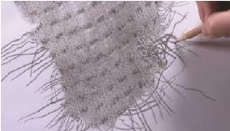
House Drawing | Children draw a house from observation; interpreting the details accurately and drawing what they see rather than what they think it looks like. | 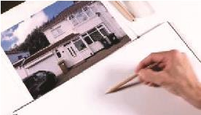
House Monoprints | Based on a section of their drawing from Lesson 1, children create a dramatic monoprint using ink. | 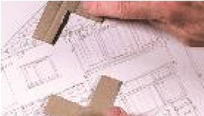  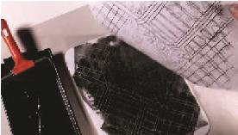

Hundertwasser House | 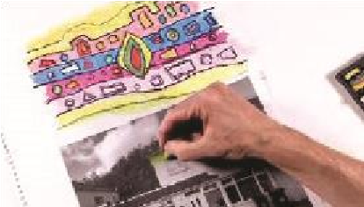  Inspired by the work of Hundertwasser, children add vibrant colours to an image of a house.  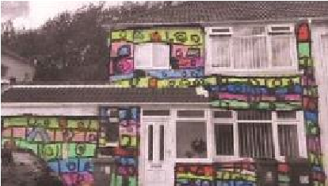
Be an Architect | 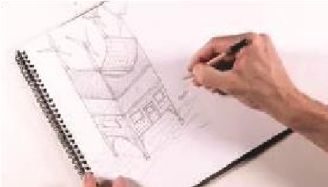  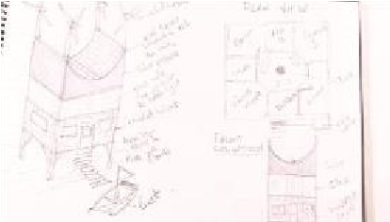  Children design a building, choosing whether to draw either a perspective view, plan view or a front elevation of their original house design.
Monument | 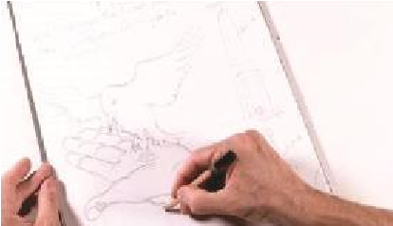  After learning about what monuments are, children design their own to reflect something they want to commemorate.  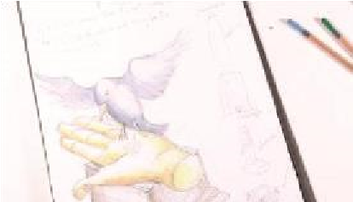

Year 5 Autumn Term:
Ideas to Support Your Child 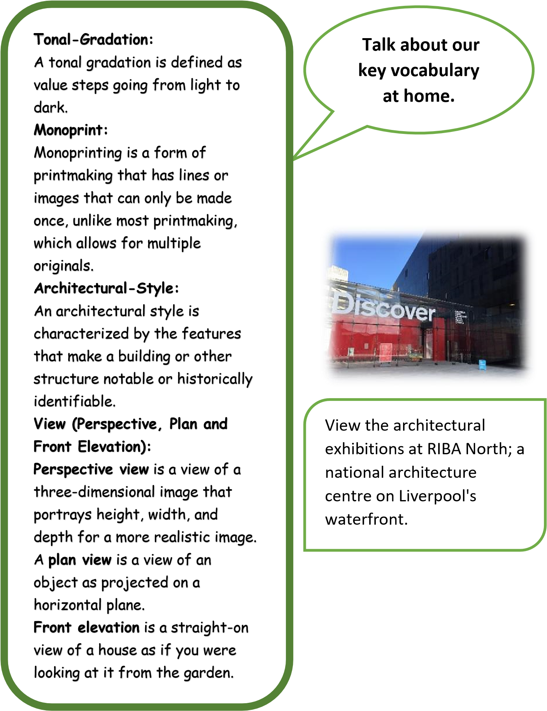

Learning at Home
Year 5 Autumn Term:
Ideas to Support Your Child’s

Learning at Home
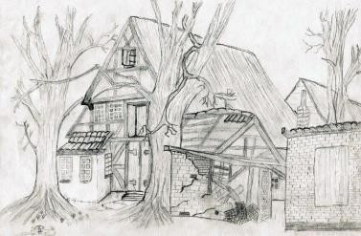

Support your child to complete an
observational drawing of a house.
Follow the link below for a guide to
observational drawing:

https://www.superprof.co.uk/blo
g
/
lear
n
-
t
o
-
dra
w
-
rea
l
-
life
/

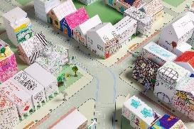

Work with your child to
crea
te a piece of artwork,
applying
their
newly
developed skills.

Support
your child to
undertake an
architectural project
. Fo
llow the link below
for resources centred on building a

model of
a

city:

https://www.curbed.com/2020/5/1/212405
3
7
/foster
s
-
an
d
-
partner
s
-
architectur
e
-
a
t
-
hom
e
-
project
s
-
kid
s

Year 5: Spring Term
Design for a Purpose
Lesson | Outline | Outcome
Design: Little Inventors | Inspired by the ‘Little Inventors Project’ founded by artist, designer and inventor Dominic Wilcox, children come up with their own ideas of what we’re missing in the world, seeing their chosen idea through to a final design. | 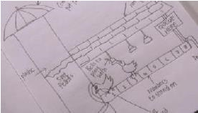
Coat of Arms | After learning about how the coat of arms originated and how they are used today, children create a design of their own. | 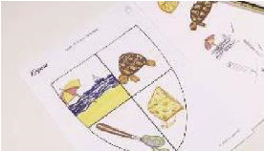
Designing Spaces | Working to a specific brief, children work collaboratively to create a design for an empty room. | 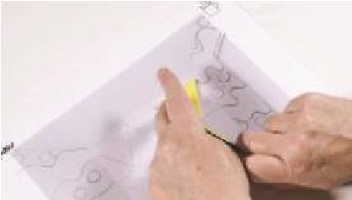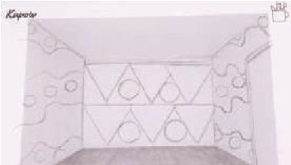

Changing Spaces |   Children use cut out shapes to help them experiment and develop their design ideas.  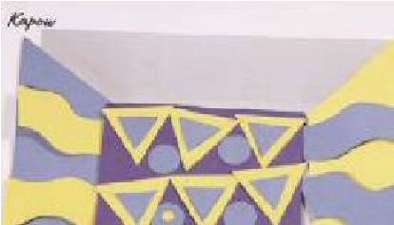
What’s in a Name? | Children are given a word as a product name, which they then devise a product idea for.
Adverts | Children create, develop and present a pitch to sell their product.

Year 5 Spring Term
Ideas to Support Your Child’s

Learning at Home
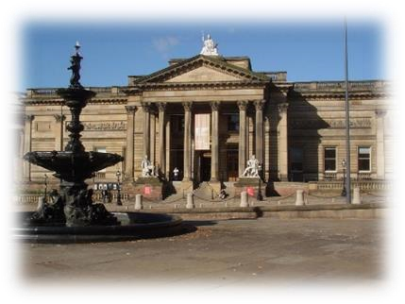

Talk about our
k
ey
v
ocabulary

at home.

Visit the Walker Art Gallery to
view the collection of
decorative art, including
ceramics, glass, metalwork
and furniture by famous
designers.

Design

:

The design process involves
developing a design proposal
related to the product
specification within a design
brief.

Prototype
:

A prototype is an early model
of a
product built to test an
idea.

Functionality
:

The functionality of a
product refers to how well it
serves its purpose.

USP
:

The unique selling point of a
product (or service) is a
feature of

the product

that
distinguishes it

from other
similar products

and makes it
more appealing.

Year 5 Spring Term

Ideas to Support Your Child’s Learning at Home

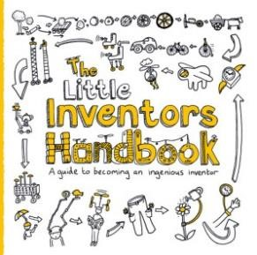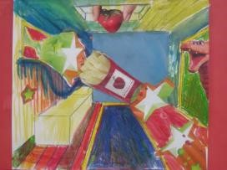

Foster your child’s creativity through enabling
them to become an inventor. Follow the link
below to find out how your child can develop
and showcase their inventions:

https://www.
l
ittleinventors.org/abou
t

Work with your child to
create a piece of artwork,
their
newly
applying
developed skills.

Supp
ort your child

to imagine, create and
design a space. F
ollow the link below for a
range of activities centred on
designing a
space:

https://diy.org/skills/6
2

Year 5: Summer Term
Every Picture Tells a Story
Lesson Outline Outcome
Learning About How Artists Work | 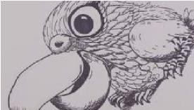  Children work imaginatively to develop an idea of their own, sourcing pictures, photos and illustrations, they  practice sketching their images before producing a final drawing.
Drawing: Picture the Poet | 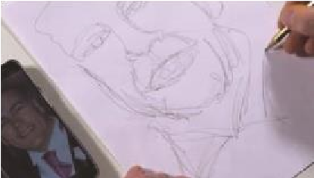  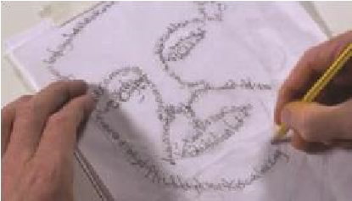  Children draw a portrait of themselves or a partner, using just one continuous line, then referring to a poem or text, write over the lines, creatively varying the size and style of their writing to suit the details of their portrait.
Clacton Pigeon Mural – Banksy |   Looking past the seemingly discriminatory tone of Banksy's Clacton Pigeon Mural, children  consider what message he was  really trying to convey and alter the image to reflect British Values.
Inspired by Rorschach | 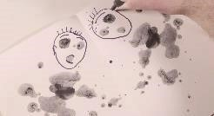  Children learn that the inkblots which inspired Andy Warhol's 'Rorschach, 1984' were a set of  psychological tests designed  by the Swiss psychologist himself, and that the message of the inkblot really comes from how it is interpreted by the viewer.
The Front Line –  John Singer Sargent | 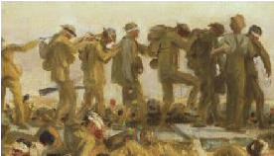  Through the piece ‘Gassed’ by John Singer Sargent, children explore the human  side of the image and work  in groups to re-enact the scene from World War 1, positioning themselves like the soldiers in the piece and taking a photo of the final composition.
Magdalene Odundo | 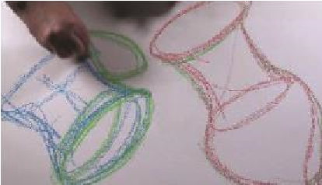  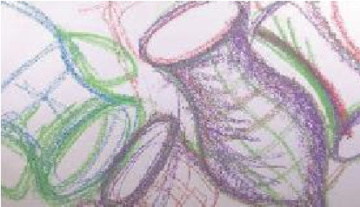  Children learn about the way in which Magdalene Odundo creates ideas for her ceramic pots by loosely playing around with shapes. Children work in the same way, with space around them, using two different  colours of chalk and their  whole bodies to make long sweeping arm movements.

Year 5 Summer Term
Ideas to Support Your Child’s

Learning at Home
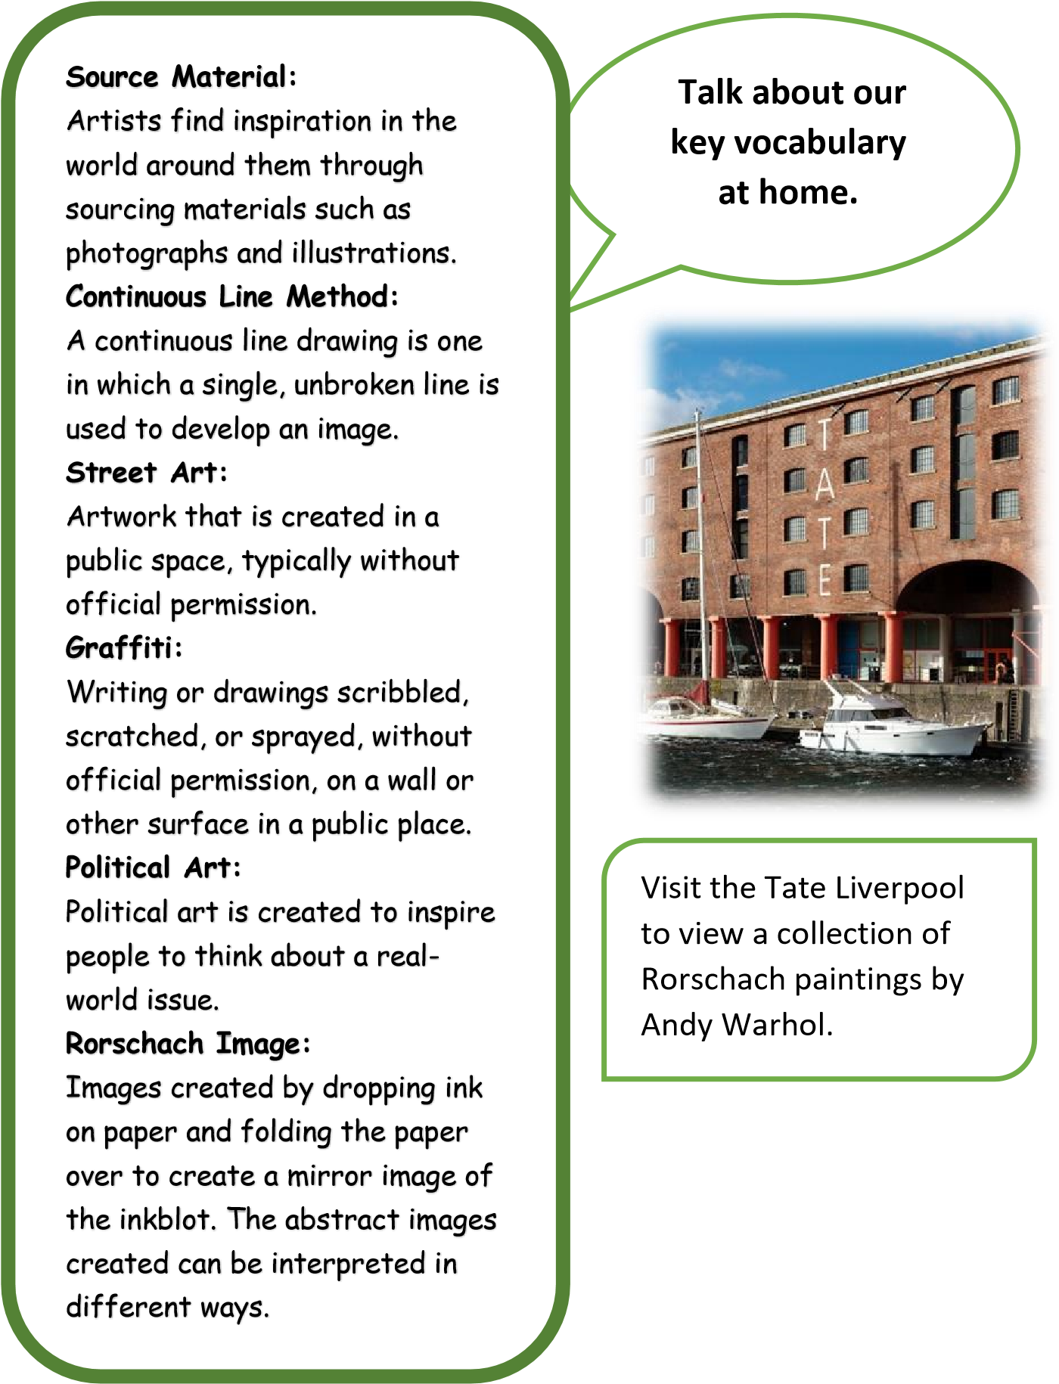

Year 5 Summer Term

Ideas to Support Your Child’s Learning at Home

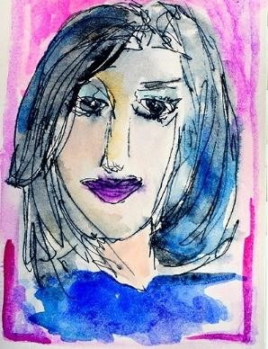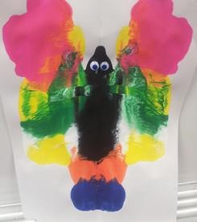

Work with your child to
create a piece of artwork,
newly
their
applying
developed skill
s.

Support your child to
create a piece of

inkblot artwork and use their
creativity
to decide what it is. Follow the link
below for a step
-
by
-
step guide:

https://dssactivities4kids.wordpress.c
o
m/2013/04/01/inkblo
t
-
art
/

Support your child to draw a portrait
using the continuous line method.
Follow
the link
below for inspiration:

d
https://daisyyellowart.com/vividlife/blin
-
r
contou
-
t
portrai

